Lecture 19: Chapter 7: Single-Dimensional Arrays
Announcements

Reading:
- Chapter 7 - Arrays

Today’s Goals
- Variable-Length Argument Lists
- Arrays Class
- Searching Arrays – Linear Search and Binary Search
- Sorting Arrays

Review Chapter 7 Terminology
Terminology
- Array
  - A data structure used to store a collection of values that are all the same type

- Index
  - Refers to a specific element within an array
  - Must be an integer or integer expression
  - The first element in an array is at index 0, the second element is at index 1, etc.

- Indexed Variable
  - Used to reference each element in an array
  - arrayReferenceVariable[index];

- Array Initializer
  - A statement where you declare, create and initialize an array

- Out of Bounds Error
  - Attempting to access an element with an index outside the range of the array is a runtime error

- Off By One Error
  - Mistakenly referencing the first element in an array with the index 1, not index 0

- Garbage Collection
  - When the Java Virtual Machine (JVM) determines that memory used by an object can no longer be reached or used by the program.

- Linear Search
  - Searching an array for a specific key value by starting at beginning and comparing the key with each element sequentially.

- Binary Search
  - Searching a pre-sorted array by splitting the array in half on each comparison.

- Selection Sort
  - Combination of searching and sorting. During each pass, the smallest element is moved to its proper location in the array.

Variable-Length Argument Lists - NOT COVERED IN LECTURE

DID NOT COVER IN LECTURE – ONLY INCLUDING IN LECTURE NOTES AS EXTRA INFORMATION

Passing a Variable-Length Argument List
- We've seen
  - Primitive formal parameters

public static int sum (int n) {

  - Array formal parameters

public static void printArray (int[] array) {

- Now we will look at a variable-length formal parameter
- It is possible to create a method that will receive an unspecified number of parameters!
- The values must be:
  - The same type
  - The last parameter in the formal parameter list
- A method can have only one variable length parameter
- Java treats this variable length parameter as an array!

General Form
- A parameter followed by an ellipsis in a method's formal parameter indicates a variable-length parameter
- The following is saying "the method sum expects an unspecified number of integer values"

public static int sum (int... values) {

- Remember, there can only be ONE of these variable-length parameters and it must be last in the list of formal parameters!

Example
static void main(String[] args) {

// Variable-length argument list
int total = sum (10, 4, 32, 15, 18);
System.out.println("10+4+32+15+18 = " + total);

total = sum(34, 56, 23, 45, 6, 7, 89, 81, 12);
System.out.println("34+56+23+45+6+7+89+81+12 = " + total);

} // main

// Sums all values passed in
// Input: Variable-length list of integer values
// Return: Sum of values
public static int sum (int... values) {
int result = 0;

// Compute the sum of all values
for (int i = 0; i < values.length; i++) {
result = result + values[i];
}
return result;

} // end sum

Arrays Class

Arrays Class
- Performing many tasks with arrays is very common
- So, Java provides an Arrays class that contains a bunch of predefined static methods!
- Arrays class
  - Lives in java.util package
  - Includes static methods for searching, sorting, filling, comparing, etc.

Examples
- This call fills the array with the value 10

import java.util.Scanner;
import java.util.Arrays;
.
.
.
// Using Arrays class
int [] myNewArray = new int[20];

Arrays.fill(myNewArray,10); Calling the static method fill
on the Arrays class. Arrays class is like
the Math class - it contains static methods
so you don't need to "create" an object
- This call sorts an array filled with random values

// Fill an array with random values and sort
for (int i = 0; i < myNewArray.length; i++) {
myNewArray[i] = (int)(Math.random() * 100);
}

Arrays.sort(myNewArray); Calling the static sort method

Note
- Just like the Math class was different, so is the Array class!
- We don't create a Math object, we don't create an Array object.
- How can we use the Math or Array class if we cannot create a Math or Array object?
  - Because ALL methods in the Math and Array class are what we called static methods
  - Static methods
    - Allow you to call the methods in a class without creating an object of the class
    - Are NOT associated with a specific object of the class
    - To call static methods you use the class name:

double squareRoot = Math.sqrt(25);

Arrays.fill (myNewArray, 10);

Searching Arrays

Searching
- In computer programming a common activity is to write code to find a specific value in an array
- Two techniques we will look at are
  - Linear search
  - Binary search

Linear Search
- Starting at beginning of an array and looking for a specific value one element at a time
- When a match is found that index of the match is returned, otherwise a -1 is returned
- The elements in the array are in any order
- Not very efficient algorithm - execution time grows linearly as the array size grows!
  - Best case: 1st element is key we are looking for
  - Worst case: last element is key or doesn't find key
  - Average: 50% of elements are examined before key is found

- Visually

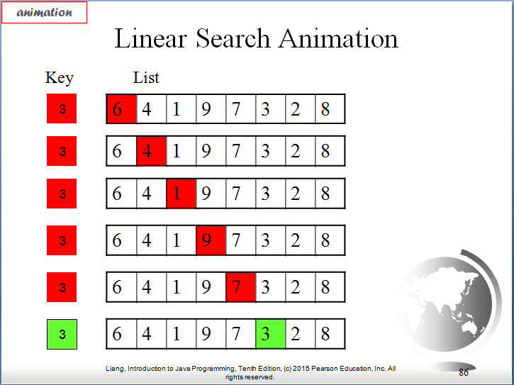

- Code for linear search:

// Finds a key value in an array
// Input: integer array, key value to search for
// Output: index or key if found, otherwise -1
public static int linearSearch(int[] array, int key) {
for (int i = 0; i < array.length; i++) {
if (key == array[i]) {
return i;
}
}
return -1;
} // linearSearch

- Trace
  - Assume we have the following in code in main

static void main(String[] args) {

Scanner input = new Scanner(System.in);
int[] arrayToSearch = new int[100];

// Fill array with 100 random numbers between 0 and 99
for (int i = 0; i < arrayToSearch.length; i++) {
arrayToSearch[i] = (int)(Math.random() * 100);
}

// Ask user for the value to look for in the array
System.out.println("What value should we search for? ");
int key = input.nextInt();

// Perform a linear search for the key
int searchResult = linearSearch(arrayToSearch, key);
if (searchResult != -1) {
System.out.println(key + " was found in location " + searchResult);
}
else {
System.out.println(key + " was not found in the array");
}

// Prove search result worked by printing the array
System.out.println("Showing proof the search worked correctly");
for (int i = 0; i < arrayToSearch.length; i++) {
System.out.println("arrayToSearch[" + i + "] = " + arrayToSearch[i]);
}
input.close();

} // main

  - The array is created
  - The array is filled with random values between 0 and 99
  - The user is prompted for the "key" value to search array for
  - The array and key are sent to the linearSearch
  - The linearSearch examines array elements sequentially looking for "key"
  - The linearSearch returns either the index or the key or a -1
  - The output is shown below:

Displays
What value should we search for? 81
81 was found in location 19
Showing proof our search worked correctly
arrayToSearch[0] = 94
arrayToSearch[1] = 58
arrayToSearch[2] = 54
arrayToSearch[3] = 94
arrayToSearch[4] = 75
arrayToSearch[5] = 40
arrayToSearch[6] = 72
arrayToSearch[7] = 48
arrayToSearch[8] = 56
arrayToSearch[9] = 7
arrayToSearch[10] = 64
arrayToSearch[11] = 71
arrayToSearch[12] = 70
arrayToSearch[13] = 75
arrayToSearch[14] = 61
arrayToSearch[15] = 51
arrayToSearch[16] = 29
arrayToSearch[17] = 44
arrayToSearch[18] = 96
arrayToSearch[19] = 81
arrayToSearch[20] = 82
arrayToSearch[21] = 34
arrayToSearch[22] = 45
arrayToSearch[23] = 13
arrayToSearch[24] = 30
arrayToSearch[25] = 53
arrayToSearch[26] = 19
arrayToSearch[27] = 89
arrayToSearch[28] = 94
arrayToSearch[29] = 71
arrayToSearch[30] = 12
arrayToSearch[31] = 76
arrayToSearch[32] = 67
arrayToSearch[33] = 52
arrayToSearch[34] = 37
arrayToSearch[35] = 69
arrayToSearch[36] = 34
arrayToSearch[37] = 4
arrayToSearch[38] = 7
arrayToSearch[39] = 50
arrayToSearch[40] = 39
arrayToSearch[41] = 99
arrayToSearch[42] = 70
arrayToSearch[43] = 3
arrayToSearch[44] = 49
arrayToSearch[45] = 56
arrayToSearch[46] = 62
arrayToSearch[47] = 3
arrayToSearch[48] = 93
arrayToSearch[49] = 88
arrayToSearch[50] = 31
arrayToSearch[51] = 72
arrayToSearch[52] = 54
arrayToSearch[53] = 32
arrayToSearch[54] = 62
arrayToSearch[55] = 20
arrayToSearch[56] = 62
arrayToSearch[57] = 50
arrayToSearch[58] = 56
arrayToSearch[59] = 20
arrayToSearch[60] = 42
arrayToSearch[61] = 11
arrayToSearch[62] = 43
arrayToSearch[63] = 85
arrayToSearch[64] = 15
arrayToSearch[65] = 7
arrayToSearch[66] = 31
arrayToSearch[67] = 30
arrayToSearch[68] = 40
arrayToSearch[69] = 52
arrayToSearch[70] = 64
arrayToSearch[71] = 85
arrayToSearch[72] = 87
arrayToSearch[73] = 44
arrayToSearch[74] = 40
arrayToSearch[75] = 53
arrayToSearch[76] = 59
arrayToSearch[77] = 52
arrayToSearch[78] = 3
arrayToSearch[79] = 34
arrayToSearch[80] = 80
arrayToSearch[81] = 90
arrayToSearch[82] = 43
arrayToSearch[83] = 68
arrayToSearch[84] = 75
arrayToSearch[85] = 12
arrayToSearch[86] = 70
arrayToSearch[87] = 63
arrayToSearch[88] = 45
arrayToSearch[89] = 36
arrayToSearch[90] = 18
arrayToSearch[91] = 63
arrayToSearch[92] = 23
arrayToSearch[93] = 79
arrayToSearch[94] = 40
arrayToSearch[95] = 32
arrayToSearch[96] = 87
arrayToSearch[97] = 10
arrayToSearch[98] = 66
arrayToSearch[99] = 76

What value should we search for? 7
7 was not found in the array
Showing proof our search worked correctly
arrayToSearch[0] = 17
arrayToSearch[1] = 28
arrayToSearch[2] = 77
arrayToSearch[3] = 14
arrayToSearch[4] = 79
arrayToSearch[5] = 93
arrayToSearch[6] = 10
arrayToSearch[7] = 5
.
.
.
arrayToSearch[93] = 27
arrayToSearch[94] = 22
arrayToSearch[95] = 56
arrayToSearch[96] = 73
arrayToSearch[97] = 84
arrayToSearch[98] = 30
arrayToSearch[99] = 96

Binary Search (CODE WAS NOT COVERED IN CLASS – ONLY GENERAL IDEA OF HOW IT WORKS)
- Another approach but it requires that the elements in the array be ordered before the search begins
- Starts with element in the middle of the array
  - If key is less than "middle" element, then only search for key in 1st half of array
  - If key is equal to "middle" element, return match!
  - If key is greater than "middle" element, then only search for key in 2nd half of array
- When a match is found that index of the match is returned, otherwise a -1 is returned

- Efficient algorithm - array shrinks by 50% after each comparison!
  - Assume the array contains 1024 elements
    - After 1st comparison - reduced search to 1/2 of the elements (512)
    - After 2nd comparison - reduced search to 1/2 of that 1st half (256)
    - After 3rd comparison - 128
    - After 4th comparison - 64
    - After 5th comparison - 32
    - After 6th comparison - 16
    - After 7th comparison - 8
    - After 8th comparison - 4
    - After 9th comparison - 2
    - After 10th comparison - 1
    - On 11th comparison 1 element left to compare with key

  - Compared to linear search
    - Best case: 1 search
    - Worse case: 1024 comparisons
    - Average: 50% of elements are examined before key is found - 512 comparisons!

Visually
- Animation
  - https://yongdanielliang.github.io/animation/web/BinarySearchNew.html

- Example: key = 8

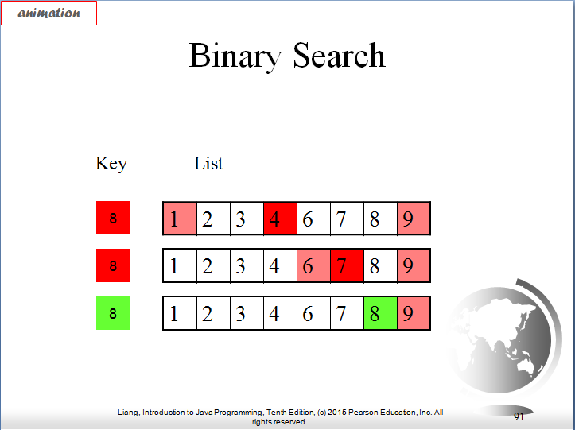

- Code for Binary Search
  - Do this incrementally because it's a bit confusing
  - Let's do it for 1 comparison (NOT COMPLETE VERSION!)
  - Visually
    - Assume array has 13 values
    - Assume array is ordered in ascending order
    - Assume key looking for is 11
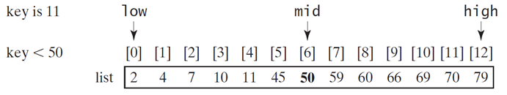

public static int binarySearch(int[] array, int key) {

// Find the index's for the first element, last element, and
// middle element of the search
int low = 0;
int high = array.length - 1;
int middle = (low + high)/2;

if (key < array[middle]) {
high = middle - 1;
}
else if (key == array[middle]) {
return middle;
}
else if (key >= array[middle]) {
low = middle + 1;
}

} // binarySearch

- Trace 1st incremental step of the code
  - Remember this code is NOT the solution yet - it's a step towards the solution!!!
  - Starting with
    - low = 0
    - high = 12
    - middle = 6

Since key < 50, low remains at 0, high = middle - 1 = 5

  - On 2nd comparison we now have only the 1st half of the array left to search
    - low = 0
    - high = 5
    - middle = 2 (5/2 = 2.5 but integer division so becomes 2)

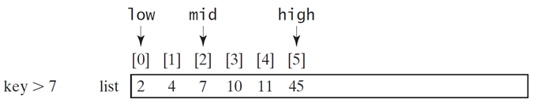

Since key > 7, low = middle + 1 = 3, high remains at 5

  - On 3rd comparison we have
    - low = 3
    - high = 5
    - middle = 4 (8/2 = 4)

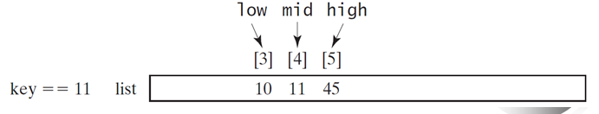
Since key = 11 we execute the statement

return middle;

  - Need to add a loop to do test over and over until there is only 1 element to compare!
  - Question:
    - How do we know when there is only one element to compare or how do we know when we can stop comparing?
    - Assume in above example we weren't looking for key = 11, say looking for key = 54
      - low = 0
      - high = 12
      - middle = 6

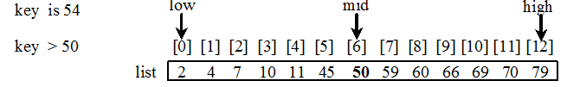

Since key > 54, low = middle + 1 = 7, high remains at 12

    - On 2nd comparison we now have only the 2nd half of the array left to search
      - low = 7
      - high = 12
      - middle = 9 (19/2 = 9.5 but integer division so becomes 9)

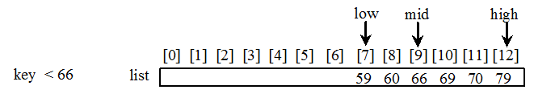

Since key < 66, low remains at 7, high = middle - 1 = 8

    - On 3rd comparison we have
      - low = 7
      - high = 8
      - middle = 7 (15/2 = 7.5)

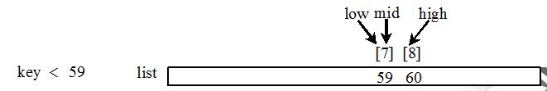

Since key < 59, low remains at 7, high = middle - 1 = 6

    - On 3rd comparison we have
      - low = 7
      - high = 6 Key to knowing value is not in array!!!

- Key to knowing we can stop search
  - When low is greater than high!!

- Adding loop to code
// Finds a key value in an array using a binary search
// Input: integer array, key value to search for
// Output: index of key if found, otherwise -1
public static int binarySearch(int[] array, int key) {

int low = 0;
int high = array.length - 1; Adding loop to continue search
while INDEX of highest element is
is larger than or equal to index
while (high >= low) { of lowest element (this means:
int middle = (low + high)/2; high hasn’t crossed over low)

if (key < array[middle]) {
high = middle - 1;
} Now determine which side of
else if (key == array[middle]) { array to search
return middle;
}
else {
low = middle + 1;
}

} // while

return -1; Return -1 when key not found
} // binarySearch Could also return low which is
point where key would be inserted

- Trace
  - Assume we have the following code in main

static void main(String[] args) {

// Perform a binary search
System.out.println();
System.out.println("Binary Search");

int[] arrayToBinarySearch = {2, 4, 6, 7, 11, 34, 56, 78, 102, 134, 155, 345};
int key = 11;
int searchResult = binarySearch(arrayToBinarySearch, key);

if (searchResult != -1) {
System.out.println(key + " was found in location " + searchResult);
}
else {
System.out.println(key + " was not found in the array");
}

key = 54;
searchResult = binarySearch(arrayToBinarySearch, key);
if (searchResult != -1) {
System.out.println(key + " was found in location " + searchResult);
}
else {
System.out.println(key + " was not found in the array");
}

} // main

Displays
11 was found in location 4
54 was not found in the array

Notes
- The array must already be ordered to use binary search!
- Binary search cuts the search in 1/2 for each comparison
- Works if there are duplicates in the list
- You can return
  - -1 to indicate value is not in array or
  - location of where the value would be inserted into the array - read p. 267 for details

Linear vs Binary Search
- Linear search is good for:
  - Small arrays
  - Unsorted arrays
- Binary search is good for:
  - Large arrays that are presorted

Sorting Arrays - NOT COVERED IN LECTURE - ONLY INCLUDING AS EXTRA INFORMATION

Sorting
- In computer programming another common activity is to write code to sort an array
- There are lots of sorting algorithms
  - Selection sort
  - Bubble sort
  - Quick sort
  - Merge sort
  - etc

Selection Sort
- Only sort we will look at – selection sort
- Process to sort array into ascending order
  - Find smallest element in array
  - Swap smallest with 1st element
  - Looking at remaining elements, find smallest element in array
  - Swap that smallest with the 2nd element
  - etc.
Visually
- Animation
  - http://liveexample.pearsoncmg.com/dsanimation/SelectionSortNeweBook.html
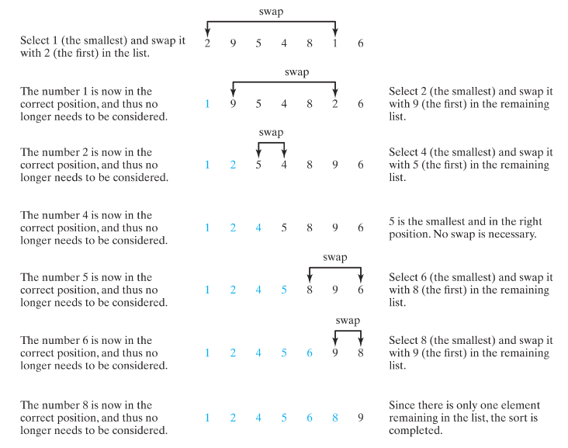

Code for selection sort
- Implement incrementally because it's a bit confusing
- Step 1: Write code for easiest case – 1 comparison (NOT COMPLETE VERSION!)
  - Find smallest element in the list
  - Swap smallest with 1st element
  - Visually
    - Assume array has 7 values in some random order

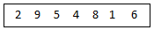

smallest value

    - We need to make it look like this

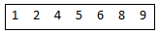

smallest value
Write code for ONLY
the 1st pass - finding
smallest and moving into
public static void selectionSort(int[] array) { 1st slot

int smallest = array[0];
int smallestIndex = 0; Find smallest element
in the array
for (int j = 1; j < array.length; i++) {
if (smallest > array[j]) {
smallest = array[j];
smallestIndex = j;
}
} If smallest element is NOT
in 1st slot, swap smallest
if (smallestIndex != 0) { with 1st element
array[smallestIndex] = array[0];
array[0] = smallest;
}
} // selectionSort

  - Trace of step 1:
    - Remember this code is NOT the solution yet - it's a step towards the solution!!!
    - Calling above code only sorts the smallest element into the 1st slot

public static void main(String[] args) {
int[] arrayToSort = {2, 9, 5, 4, 8, 1, 6};
printArray method to
System.out.println("*** Array BEFORE sort ***"); display the elements
printArray("arrayToSort", arrayToSort); of an array

selectionSort (arrayToSort); Using code above to
sort only smallest
System.out.println(); element
System.out.println("*** Array AFTER sort ***");
printArray("arrayToSort", arrayToSort);

} // main

Displays
*** Array BEFORE sort ***
arrayToSort[0] = 2 Start by comparing 2 to every element
arrayToSort[1] = 9
arrayToSort[2] = 5 Smallest element in the array is 1
arrayToSort[3] = 4
arrayToSort[4] = 8
arrayToSort[5] = 1
arrayToSort[6] = 6

*** Array AFTER sort ***
arrayToSort[0] = 1
arrayToSort[1] = 9
arrayToSort[2] = 5 selectionSort code above found smallest
arrayToSort[3] = 4 and swapped it with what was in the 1st slot
arrayToSort[4] = 8 (so it swapped the number 2 and the number 1)
arrayToSort[5] = 2
arrayToSort[6] = 6
arrayToSort[5] = 2
arrayToSort[6] = 6

- Step 2: Write code for all cases
  - Find smallest element in the list
  - Swap smallest with 1st element
  - Looking at remaining elements, find next smallest element in the list
  - Swap that smallest with the 2nd element
  - Repeat until all values are in correct place

  - Need another loop to run through the method for each element in the array

public static void selectionSort(int[] array) {
Process each element in the
array. No need to process
for (int i = 0; i < array.length-1; i++) { last element.

For this run through array
set smallest to the value
int smallest = array[i]; in slot i
int smallestIndex = i;
Start looking from slot i+1
for (int j = i+1; j < array.length; j++) { on for any value less than
if (smallest > array[j]) { value currently in smallest
smallest = array[j];
smallestIndex = j;
} If a value less than
} // for j smallest was found
swap smallest and this
if (smallestIndex != i) { even smaller value
array[smallestIndex] = array[i];
array[i] = smallest;
}
} // for i
} // selectionSort

